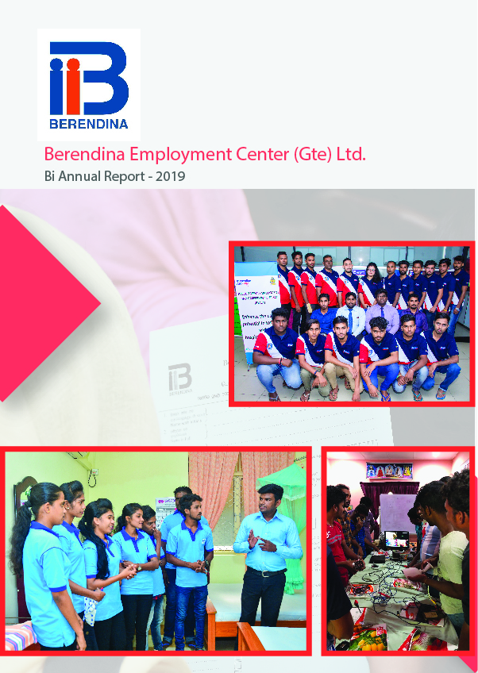

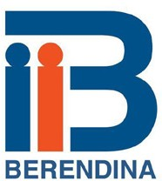



**Contents**  **Page #**

Geographical Coverage 02

New strategic direction 03

Core Activities 04

Outputs and Outcomes 05

Target Group 06

Overview of youth employment 07

Executive summary 08

Stakeholder Meetings 08

Bright Student Scholarships 09

Kick off events & household survey 10

Career Advise & Guidance 10

Establishing Career Information Center 11

Improved Soft Skills for Youth 13

Professional Training 14

Vocational Training 15

Youth Directed to Government VT 17

Mini Job Fair and Job Placement 17

TVEC Consultation Workshop 18

Human Resource Management 19

Variance Report 20

**Imparting skills and empower marginalized youth**

**Our Vision**

“Our Vision is to create an empowered, equitable Society where poverty does not exist”

**Our Mission**

“Empower marginalized youth by enabling them to find appropriate employment opportunities through education, career guidance, skill development and job linkages while contributing to develop conducive policy environment”

”

**Our Core Values**

1.

1. **Anti-Corruption**

Berendina Employment Center has a zero-tolerance to corruption. This applies to sta, training partners, youth, students and when dealing with authorities.

1. **Gender Equality /Gender Mainstreaming**

Berendina Employment Center advocates for gender equality and mainstreaming by encouraging young women to receive vocational and professional training. This is done through partnerships with likeminded organizations and mobilizing VTIs to enroll female youth. Equal opportunities are also provided for our staff.

1. **Transparency**

Berendina Employment Center’s procedures aim to give full transparency in resources used and optimize the application of those resources to serve our mission.

1. **Anti-Discrimination**

Berendina Employment Center is committed to the principle of equal employment and education opportunities. We provide an environment free of Discrimination and harassment on the grounds of gender, race, disability, sexual orientation, or parental or marital status.

|  |  |  |  |
| --- | --- | --- | --- |
| **Province** | **District** | **# of Branches** | **DSD** |
| Sabaragamuwa | Kegalle | 1 | Galigamuwa,Warakapola,Ruwanvella, Bultahkopitiya |
| Central | Nuwaraeliya | 2 | Ambagamuwa , Nuwara eliya |
| North Central | Anuradhapura | 1 | Manupa,Kahadahesdeliya,Therepane |
| Eastern | Trincomalee | 1 | Town & Gravets ,Kinniya,Thampalakamam |
| Batticaloa | 1 | Pattipalai , Porathivu Pattu,Eravurpattu |
| Northern | Mullaitivu | 1 | Maritimpattu, puthukudiyiruppu,oddusuddan |
| **5 provinces** | **6 districts** | **7 Branches** | **18 DSDs** |

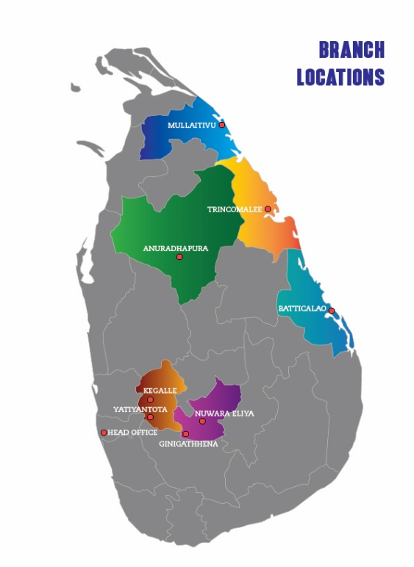**Geographical CoverageNew strategic direction (June 2018 to December 2021)**

Taking into consideration the dynamic changes in both internal and external environment during the recent past, the Berendina Employment Center (Gte) Ltd has developed its strategic direction for the next three and a half years (June 2018 to Dec.2021). The overall achievements of the preceding Strategic Plan (2014-2016) reveal a positive but mixed organizational performance in terms of growth, expansion and contributing for sustainable changes. Thus, the year 2017 was considered as year of transition to new strategic plan of 2018-2021 while implementing few pilot projects such as Soft skills for youth and ICT for livelihoods. Effectiveness of these new interventions also assessed through review which influenced the management decision to meaningfully integrate in to the new strategic plan.

BEC’s programs for skill development and youth employment have been constantly evolving over the decades responding to the changing environment in which BEC is working and the lessons that BEC learned from its work and the work of others. The strategic planning session reinforced to think and review of BEC’s works in the past, contextual demand, challenges and with the best prediction of the next four years on the Skill development and Employment sector in the country

Through this new Strategic Plan BEC is ensuring its commitment to be relevant to the country’s priority and contribute for the sustainable development The purpose of the 2018-2021 strategic plan is to revamp the existing approaches, procedures and system of BEC to make it more relevant to the evolving context and align BEC with the country level strategic objectives and sustainable development goal of skills development and employment. By the end of June 2019 BEC has completed its first year in implementing new strategy.

**Core Activities**

**Education**

Marginalized bright students have increased access to advance level education through financial and mentoring support which will lead towards attaining higher education

**Career Guidance & Counselling/Advise**

Marginalized youth are strengthened to recognize appropriate career path ways by developing a contextually responsive career guidance module as well as improving the delivery of career guidance services by capacitating relevant stakeholders.

**Skills Development**

Marginalized youth have increased employability through emerging industrially demanding soft skills, and Vocational and Professional Skill development training

**Job Placement & Linkages**

Marginalized youth have increased access to productive and decent employment by directing them to existing job markets & ensuring their employability through robust follow up mechanisms

**Strategy plan _theory of change**

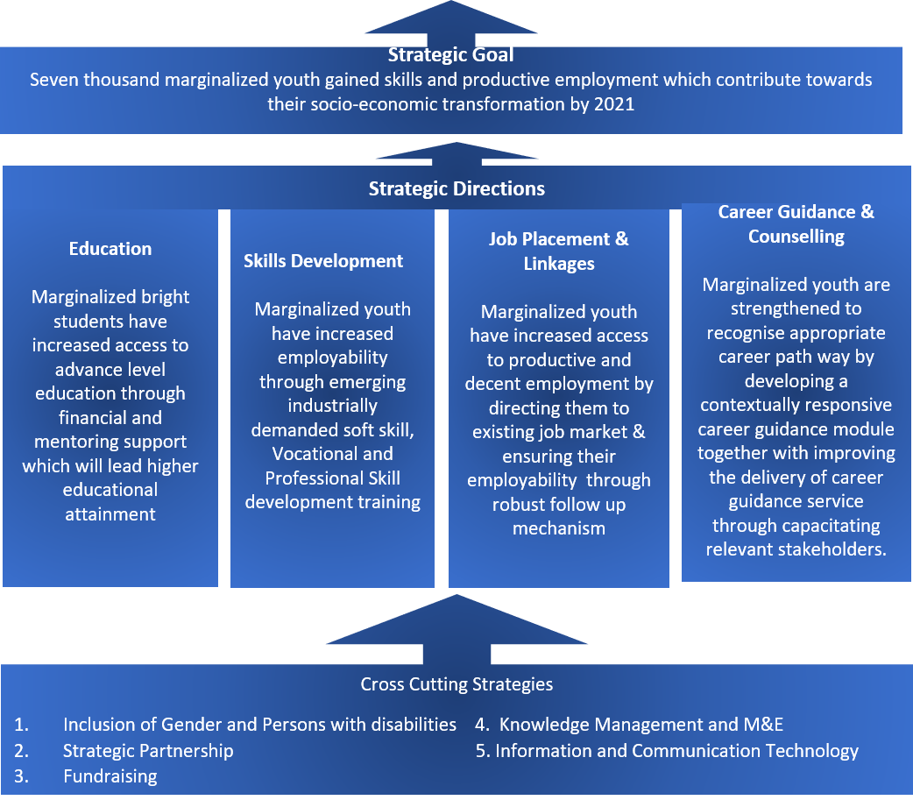

**Outputs and outcomes**

**Outputs and Outcomes**

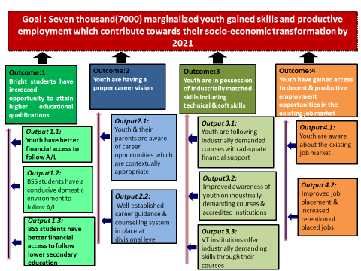

**Target Group**

BEC is working with the marginalized youths in the selected Districts. However, BEC defined the specific target group among youth as male and female who are between the age group of 15 – 30 years.

1. **Students of General Certificate of Education, Advance Level:**

Marginalized, poor but bright students who are studying Advance Level will be supported under the Bright Student Scholarship Schemes to continue their education without any issues related to finance and while creating a conducive environment at home that encourages education.

1. **Youth who sat the General Certificate of Education, Advance Level exam**

Marginalized youth who sat Advance Level exams but couldn’t secure university entrance will be supported for the career guidance, skill development and employment. This also includes the youth who were supported under the Bright Student Scholarships.

1. **General Certificate of Education, Ordinary Level qualified youth who are over 18 years**

Marginalized youth who have passed Ordinary Level exams but didn’t pursue Advance level due to family burden or any other reasons will be supported for Career guidance, Skill development and employment. However, they must be above 18 years as the government of Sri Lanka passed the act for compulsory 13 years education for all.



**Overview of Youth Employment in Sri Lanka**

labor demand of the country reveals that nearly half a million vacancies (labor demand) exists in the private sector enterprises (excluding the micro enterprises). However, the Sri Lanka Labor Force Survey, 2016 has shown that there are 360,000 unemployed persons seeking employment. It further that there is a potential labor force of 200,000 who are not actively seeking employment but ready to work if an opportunity comes. The unemployed can be absorbed to the private sector immediately by matching their skills and capacitates and the potential labor force also could be made as employed by appropriate trainings and carrier counselling programmes.

In Sri Lanka though the overall unemployment rate is less than 5% the youth unemployment is high as 21.6% (in labour force survey 2016). The youth unemployment rate in 2016 indicates that one out of every five economically active youth (Youth who are/were employed or unemployed during the previous one week of the labor force survey 2016) are unemployed. Youth unemployment has been in rise during the recent past. Since 2012, youth unemployment in the country has been increasing at a CAGR of 5.86% (from 17.2% in 2012 to 21.6% in 2016). However, the recent increase in youth unemployment is the result of the increase in unemployment among both male and female gender categories.

Higher unemployment rates are observed among the lower age of groups of youth, with an unemployment rate of 65 % recorded within the 15-19 age group. Even though the unemployment rate decreases, note that even the lowest unemployment rate of 15 %, which is recorded in the age group 30-35, is still almost four times higher than the country’s overall level of unemployment. The high unemployment rates at the lower age group is evidence of the poor school to work transition experience by Sri Lankan youth. On average, an unemployed youth spends 21 months searching for employment. This suggests that unemployed youth are unable to access the right information that is needed to secure suitable jobs. While employed youth possessed (on average) 10 months of work experience prior to commencing their current job, unemployed youth had only one month of prior work experience. Lengthy periods of unemployment are not favored by recruiters and are associated with skill depreciation- source from USAID/YouLead project survey.

**Bi Annual Progress Report – January to June 2019**

**Executive Summary**

This mid-term report provides a comprehensive understanding of activities implemented by Berendina Employment Center (BEC) during the reporting period January to June 2019. BEC prepared a complete annual plan and the activities are being implemented accordingly. BEC continued to uplift the lives of marginalized youth through Career Advice and Guidance, soft skills development, skills development, Job Linking with the Private Sector and providing Bright Students Scholarships. Highlights of achievements during the reporting period is as follows.

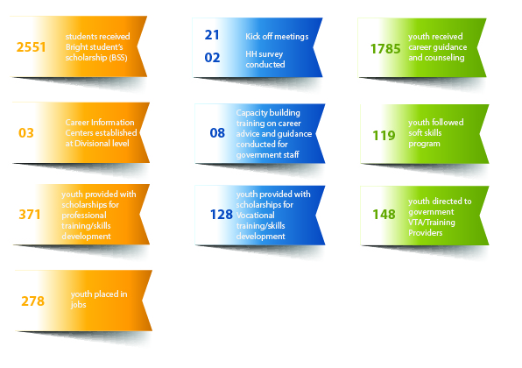

**Progress of Activities**

1. **STAKEHOLDER MEETING**

BEC has changed its strategy and It was decided to limit the working area (Depend on the district) geographically and implement comprehensive program to generate concentrated results and impacting on the real needy target group. Therefore, during 2019 BEC expanded additional 10 Divisional secretariat division from BEC operational districts for identify the sufficient number of youth and being implemented the activities. Since the divisional secretariat is key change agents of BEC new strategy, BEC conducted stakeholder meetings at expanded divisional secretariats too with other potential stakeholders in order to provide orientation on BEC new strategy and future interventions. 10 stakeholder meetings conducted at 10 expanded divisional secretariat divisions and 859 government staff participated and most of the meetings presided by either by Divisional Secretariat or Assistant director of planning.

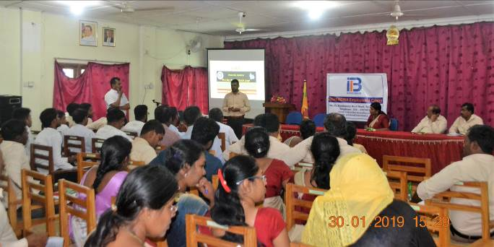

**OUTCOME_01:** Bright students have increased opportunity to attain higher educational qualifications

1. **BRIGHT STUDENTS SCHOLORAHIP PROGRAM (BSS)**

This scholarship is awarded to students from very poor families with a per head income of less than LKR 5,000 per month or Samurdhi recipient families. Those who obtain a minimum of 6 credit passes in one sitting at the G.C.E. Ordinary Level examination including a ‘B’ pass in Mathematics is eligible for the program. Students in Arts and Commerce streams were provided a monthly allowance of LKR 1,000 and students in the Science and Mathematics streams were provided LKR 1,500 per month to cover their educational expenses. The students’ progress is closely monitored by BEC and the continuation of the scholarship depends on their individual performance.

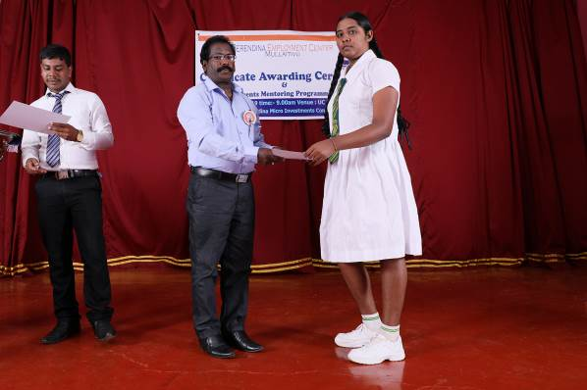

During the reporting period, BEC provided a total of 2551 scholarships which includes 241 students who passed grade 5 scholarships exam in plantation areas (Kegalle and Nuwara Eliya) and 153 university students in addition to the A/L students of these scholarship recipients. And also includes 889 students to be sat for the G.C.E. A/L examination held in August 2019.

**Students and Parent Mentoring**

Teachers and students are both key individuals during the learning process. It is important to guarantee their freedom of interaction, safety and respect within the learning environment, not only in schools but also at household level. Therefore, there is a significance role for parents to play in creating a suitable learning environment at home for their children to study.

During the reporting period BEC not conducted student and parent mentoring programs, since the O/L result released by April 2019 and the selection process of new BSS students was not completed

**OUTCOME_02:** Youth are having a proper career vision

1. **KICK OFF MEETINGS AND HOUSEHOLD SURVEY**

As per the new strategy, BEC conducted kick off events and house hold survey to identify youth, those who are come under BEC target group. Before conducts the career guidance program, youth were identified through kick off events and house hold survey.

During the reporting period, 21 kick of events and 02 house hold survey completed. By this activity 2363 youth identified for BEC assistance which including 884 Male and 1479 female for further process.

1. **CAREER ADVISE/COUNSELLING AND GUIDENCE**

Career advise/counseling and guidance is a comprehensive developmental program that is designed to assist individuals in making informed decisions about their future career. It provides relevant guidance that enable them to follow a career path of their interest. Therefore, career guidance seeks to empower youth to select a suitable career path thereby creating confidence in them-selves and their chosen path.

Counseling has been very important for youth who were identified through Kick off meetings, who are out of school and completed their either O/L or A/L so that they have guidance to plan their future. During BEC’s career guidance programs, a career test was done for youth and career analysis was carried out based on the results. This enable youth to identify best fitting career option for them.

33 career guidance and counselling programs conducted during the reporting period, with a participation of 1,785 youth (Male- 613 and Female- 1,172).748 (Male-240 and Female-508) youth identified for financial support, out of which 94 youth financially supported and directed to Private Vocational Trainings and 354 youth financially supported and directed to Professional Trainings during this reporting period. Furthermore, 206 youth directed to appropriate jobs according to their skills and capacities and 148 directed to government VT/Institutes.

33 CG conducted

**Establishing Career Information Centers**

Carrier Guidance plays an important role in minimizing the issue of unemployment. When exploring a career, it is very important to match the interests and skills of the job seeker with a suitable career available in the labor market. BEC is closely working with Divisional Level Skill Development officers. During consultation meetings had, BEC identified that there still remain certain gaps in providing these career guidance and counselling services in Divisional Secretariat levels. there has been no collaborative mechanism to provide a proper career guidance service in DSD level. Realizing that BEC established 03 career information centers in Anuradhapura, Batticoloa and Kegalle districts areas where it operates.

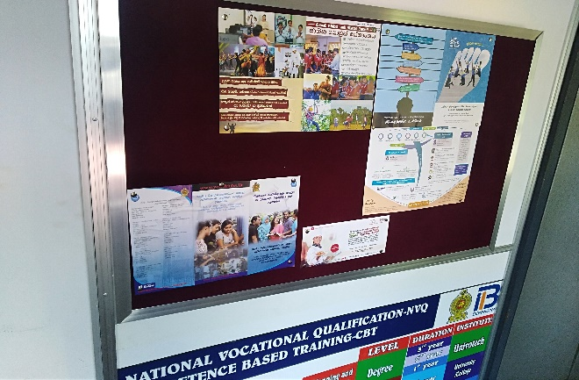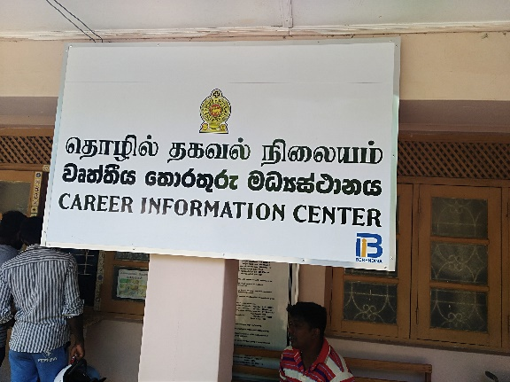

**Career Counseling Training for Development Officers**

As a guiding service in Society career guidance can direct youth soon after they drop from the schools and grow them in the vocational education system as skilled labour. The problem creates that there is not having a proper career guidance service in village level.

Developing skills on career counselling of village level development officers helps youth to understand the potential with them and can increase youth interest in that field and suggest the right course for them. During the reporting period, BEC conducted 08 career advise/counseling trainings to trained 538 Divisional Secretariat level development officer including filed level staff on career counseling/advise. It is greatly helps them to improve their skills on career counseling/advise and to work more on sensitive manner when it comes to youth economic development.

**Training of Trainers (ToT ) on Career Advise/Counselling and Guidance**

Conduct training of trainers on career guidance for district level trainers and BEC staff is one of the activity under outcome 2 of BEC log frame. The objective of the ToT is to improve the capacity of the district level trainers and BEC staff. Two residential ToT training on career guidance and counselling/advise conducted for identified district level trainers (who have been engaging career guidance services in the BEC operational districts including government staff) as Sinhala and Tamil medium separately. Each training was 3 days. Altogether 45 district level trainers and 18 BEC staff participated. the ToT was facilitated by resource persons from Tertiary Vocational Education Commission of Sri Lanka.

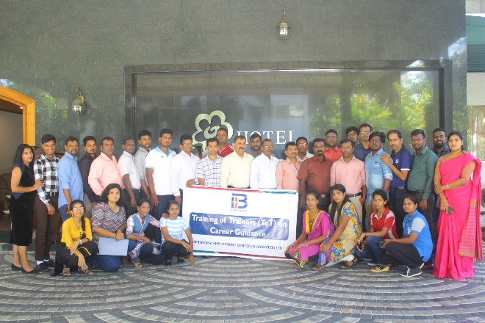

**OUTCOME_03:** Youth are in possession of industrially matched skills including technical & soft skills

1. **IMPROVING SOFTSKILLS FOR YOUTH**

Vocational, technical, professional, and entrepreneurial skills do not guarantee lifelong success in the evolving workplace context. Most of employers says that Soft skills like time management, personal responsibility, communications, ability to work independently, critical thinking, and the ability to work on a team are imperative. The same employers also report that these very skills are often lacking in prospective employees and constitute a major part of the skills gap. With this market knowledge, BEC took initiatives to conducted soft skills development training programs for selected youth in the areas we work, during the period of reporting BEC trained 119 youth on soft skills aiming to increase the employability.

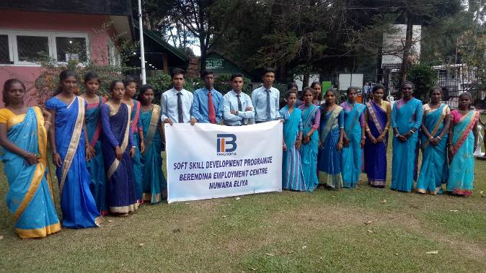

1. **PROFESSIONAL TRAINING FOR YOUTH**

BEC continued to support professional courses for O/L and A/L qualified youth who were not successful in entering in to university or any other higher education. These courses are high in demand mainly and it is costly. The demand for Professional skills by the expanding industries such as health, ICT become significant in Sri Lanka with the increased foreign direct investments. BEC has also piloted supplying professional skilled personal in the previous years and experienced the higher impact on investing and promoting professional courses such as accountancy, nursing, ICT among the poor youth that provide higher income earning opportunities. Building on the experience, BEC intended to provide opportunities for youth to enroll in the professional courses.

During the reporting period, BEC provided 354 scholarships, which includes 244 female youth and 110 male youth to undertake professional courses. selection was done based on their income level. While female youth undertook courses in 13 categories, male youth undertook courses in 12 categories. Youth were mobilized and identified through career guidance programs conducted in partnership with the Divisional Secretariat, BMIC, career fair and the Estate management.

Since May 2018, Berendina Employment center (Gte) Ltd contracted a partnership with Scope Global which is the implementing partner of Skills for inclusive growth Project to carry out Recruitment, Employment, Careers in Tourism project, locally know as REACT and implementing in four districts, namely, Polannaruwa, Trincomalee, Ampara and Batticaloa. Project is funded by the Department of Foreign Affairs and Trade and implemented by Scope Global in partnership with the Sri Lankan Ministry of Skills Development and Vocational Training. S4IG supports sustainable job creation and business growth along the tourism value chain in Sri Lanka.

During period of reporting BEC provided 17 Professional training scholarships for youth which include 02 Male and 15 Female provided under skills for Inclusive Growth Project specially focusing tourism sector skills development

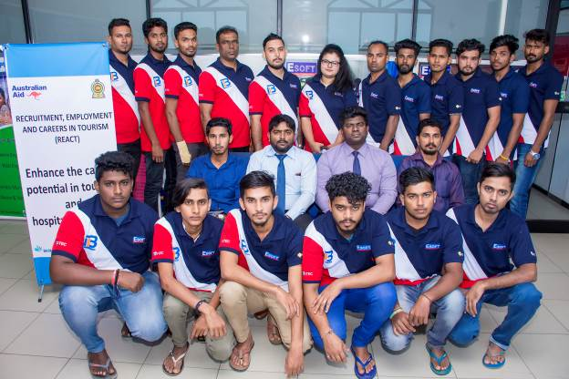

**6.1 Sector wise Classification _Professional Training _Table**

|  |  |  |  |  |
| --- | --- | --- | --- | --- |
| **Skills development /Training Title** |  | **Gender** | | % |
| **# of total Professional** | **Male** | **Female** |
| **AAT/Chartered/Banking/Accounting** | 21 | 6 | 15 | **6%** |
| **Diploma in IT** | 23 | 7 | 16 | **6%** |
| **HRM** | 46 | 8 | 38 | **12%** |
| **Pre School Diploma** | 27 | - | 27 | **7%** |
| **Computerized Accounting** | 102 | 46 | 56 | **27%** |
| **Diploma in Business Management** | 52 | 5 | 47 | **14%** |
| **Diploma in Web Engineering** | 8 | 4 | 4 | **2%** |
| **Graphic Designing** | 25 | 3 | 22 | **7%** |
| **Diploma in Heritage Management** | 1 | - | 1 | **0%** |
| **CIMA** | 1 | - | 1 | **0%** |
| **Marketing** | 27 | 12 | 15 | **7%** |
| **Photographer** | 7 | 7 | - | **2%** |
| **Plant Nursery Development Assistant NVQ 4** | 16 | 12 | 4 | **4%** |
| **Diploma in Special Need Education** | 2 | - | 2 | **1%** |
| **Diploma in Drawing and Painting** | 1 | 1 | - | **0%** |
| **Higher National Diploma in Building Service Technology** | 1 | 1 | - | **0%** |
| **Diploma in computer accounting** | 1 | - | 1 | **0%** |
| **Diploma in travel, tourism & hospitality management** | 10 | - | 10 | **3%** |
| **TOTAL** | **371** | **112** | **259** |  |

1. **VOCATIONAL TRAINING FOR YOUTH**

Vocational education or vocational education and training prepares youth for jobs that are based on manual or practical activities, traditionally non-academic, and totally related to a specific industry, occupation, or vocation.

During the reporting period, BEC provided 94 scholarships, which includes 44 female youth and 50 male youth to undertake professional courses. selection was done based on their income level. While female youth undertook courses in 07 categories, male youth undertook courses in 11 categories. Youth were mobilized and identified through career guidance programs conducted in partnership with the Divisional Secretariat, BMIC, career fair and the Estate management.

Since May 2018, Berendina Employment center (Gte) Ltd contracted a partnership with Scope Global which is the implementing partner of Skills for inclusive growth Project to carry out Recruitment, Employment, Careers in Tourism project, locally know as REACT and implementing in four districts, namely, Polannaruwa, Trincomalee, Ampara and Batticaloa. Project is funded by the Department of Foreign Affairs and Trade and implemented by Scope Global in partnership with the Sri Lankan Ministry of Skills Development and Vocational Training. S4IG supports sustainable job creation and business growth along the tourism value chain in Sri Lanka.

During period of reporting BEC provided 34 Professional training scholarships for youth which include 25 Male and 09 Female provided under skills for Inclusive Growth Project specially focusing tourism sector skills development

**7.1 Sector wise classification vocational training Table**

|  |  |  |  |  |
| --- | --- | --- | --- | --- |
| **Skills development /Training Title** |  | **Gender** | | % |
| **# of Total VT** | **Male** | **Female** |
| **Tailoring** | 1 | - | 1 | **1%** |
| **IT (Certificate Level)** | 3 | - | 3 | **2%** |
| **Hotel/house keeping** | 30 | 26 | 4 | **23%** |
| **Beauty Culture** | 14 | 3 | 11 | **11%** |
| **Lathe Work** | 1 | 1 | - | **1%** |
| **Fashion Designing** | 16 | 1 | 15 | **13%** |
| **Electrician** | 1 | 1 | - | **1%** |
| **Certificate in Television and Radio Announcing** | 2 | 1 | 1 | **2%** |
| **Lab Assistant** | 1 | 1 | - | **1%** |
| **Civil Draughtsman ship** | 1 | 1 | - | **1%** |
| **Nursing** | 21 | 3 | 18 | **16%** |
| **Pharmacy Assistant** | 1 | 1 | - | **1%** |
| **CCTV** | 13 | 13 | - | **10%** |
| **Pre Sea Engine Rating Motorman** | 8 | 8 | - | **6%** |
| **Pool life guard** | 15 | 15 | - | **12%** |
| **Total** | **128** | **75** | **53** |  |

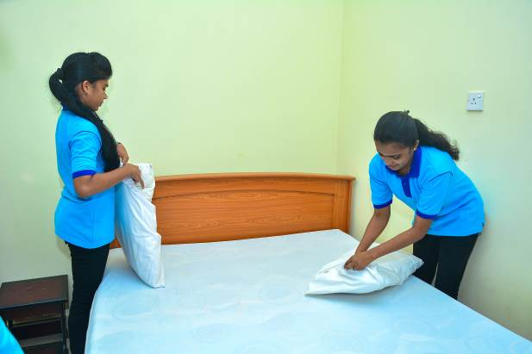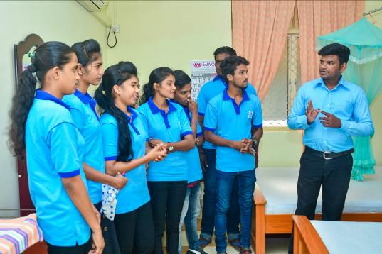

1. **YOUTH DIRECTED TO GOVERNMENT VTA**

Direct to the government VTA is one of the activity under new strategy. Through the career advice/counselling and guidance program, 148 youth directed to government VTA/institutes includes 54 Male and 94 Female.

**OUTCOME_04:** Youth have gained access to decent & productive employment opportunities in the existing job market

1. **MINI JOB FAIR AND JOB PLACEMENTS & LINKAGES**

Job placement is a key outcome of the BEC activities. 206 youth successfully placed at job following the skills development and career fair activities includes 92 Male and 114 Female.

During period of reporting BEC provided employment for 72 youth, which include 56 male and 16 female provided under skills for Inclusive Growth Project specially focusing tourism sector skills development. Altogether 278 youth placed jobs.

**Salary range of job placement**

During the reporting period, a salary survey was conducted among youth who were linked with jobs during the period of reporting. The below chart shows the salary ranges of jobs linked by BEC. According to the analysis, 56 % of youth earn an income over LKR 15,000 per month.

1. **TVEC THINK TANK/CONSULTATION WORKSHOP**

BEC committed towards uplifting the lives of marginalized youth and providing Professional & Vocational Training Scholarships. When carrying out these interventions, Berendina Employment Centre partners with a number of Vocational Training Providers.

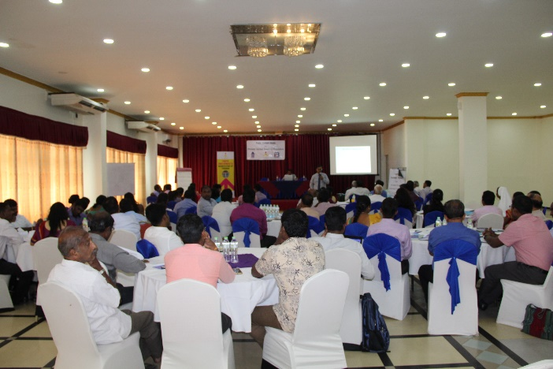However, it has been identified that there is a need to aware Private Vocational Training Centers in the BEC operational districts to follow standards of the Tertiary and Vocational Education Commission (TVEC) and the importance of obtaining Center Registration. It is further identified that students who obtain services from these training centers do not receive the best training with recognized certificates since the courses are not accredited.

Therefore, in order to create awareness among private training providers on how to follow the Center Registration process, understand the registration criteria, its renewal process and the required standard, 01 TVEC consultation workshop was conducted at northern province during this reporting period and covered 05 districts such as Mullaithivu, Jaffna, Kilinochchi, Vavuniya and Mannar. The consultation workshop was facilitated by Mr. T. Senthuran, Deputy Director, center registration and course accreditation, TVEC. There were participants from 45 Private Vocational Training providers from northern province, who newly applied and without for the TVEC registration

Berendina Employment Centre partnered with the YouLead Project to facilitate this consultation workshop. YouLead is a U.S Agency for International Development (USAID) funded 4-year project that aims to establish a skilled workforce and link youth with more productive careers. YouLead improves Technical and Vocational Education and Training, and undertakes activities to support and strengthen students, teachers, institutions and entrepreneurs.

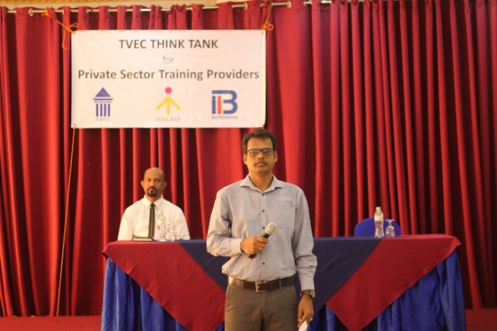The consultation workshop also provided awareness on the importance of course accreditation and the inclusion of soft skills in course modules to increase employability of participants/ students. It also provided a better understanding about expectations of TVEC to the new training providers in order for them to provide quality services/ trainings. They were also made aware about the skills gap and demand in the country, which needs to be considered when offering suitable courses in the Northern Province that are industry driven. Following the sessions, an open discussion and feedback was also carried out to clarify the participants doubts too.

1. **CROSS CUTTING STATERGIES**

Improving the skills persons with Disability is considered to be a one of cross cutting theme in BEC strategy. During the reporting period, 01 workshop conducted at Batticaloa and 42 persons with disabilities participated the initial discussion and expressed their interests. The workshop was facilitated by Mr. David, who is one of the resource person working towards the development of Persons with disability. BEC is planning to develop a comprehensive skills and business development plan for person with disability and expect to support them by last quarter of this year.

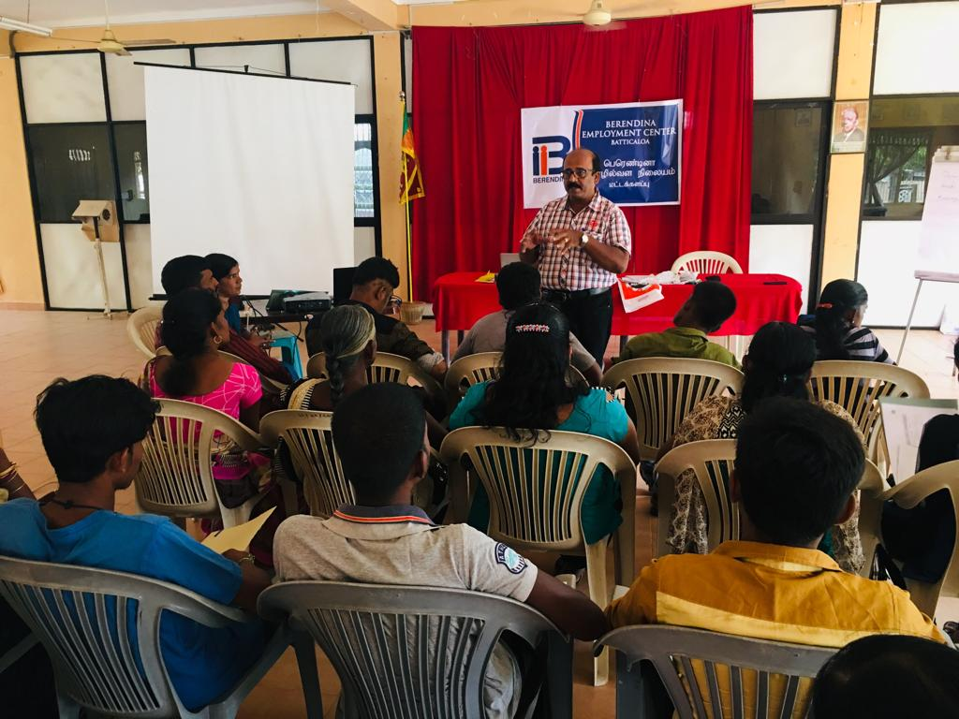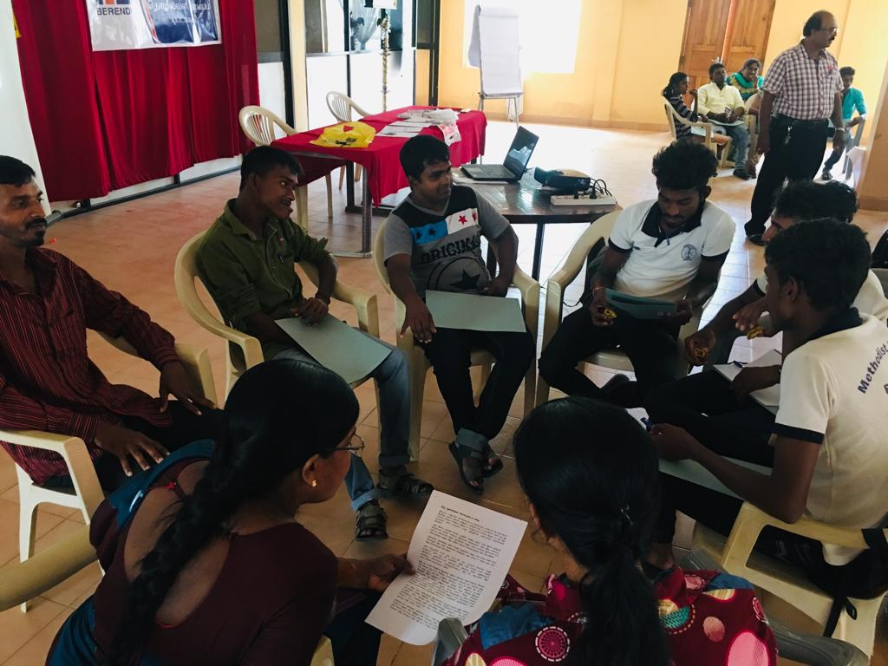

1. **HUMAN RESOURCE MANAGEMENT**

Human resource is one of the main resources of an organization that deals with or provides advice when dealing with issues and needs or people in an organization. HR activities include hiring, compensation, performance management, organization development, safety, wellness, benefits, employee motivation, communication, administration, and training.

As of June 2019, Berendina Employment Center (Gte) Ltd (BEC) has a staff capacity of 18. Out of which 33.33% are female staff. Total number of permanent staff are 6 employees.

**Staff training and development**

Training is vital for organizational development and success. It is beneficial for the employer as well as the employee. An induction training is provided for new recruits that join with Berendina. This training enables them to familiarize with the organization’s mission, vision, objectives, rules and regulations and the working conditions. When current employees are promoted or given a career growth opportunity, relevant trainings and exposure is provided in order to prepare them to undertake higher level responsibilities. Through these trainings, BEC expects to increase efficiency and productivity of employees, thereby reducing the need for constant supervision. During the reporting period, BEC provided Training of Trainers (ToT) on career advice and guidance to BEC staff too. The training was three days residential training and conducted at Polonnaruwa and the resource person from TVEC, Colombo.

1. **VARIENCE REPORT**

During the reporting period, the overall burning rate against year to date budget was 65%. Career guidance program and kick off events to be continued during the 3rd quarter of this year, since expanded additional DSDs to identify required number of youth and conducted with low budget. And also career information centers also to be established by 3rd quarter of this month. It was delayed to commence the training for identified youth, since some intakes will be in July this year. And also the payments of soft skills training, professional and vocational trainings are committed as well as installment basis. Most of the participants linked jobs with conducted few mini job fairs and to be conducted by next half of the year, since most of the skills development activities are ongoing and expect to be completed by last quarter, thus resulting in a low burning rate.

**Annexure _01_ Variance Report _BEC ( Jan-June 2019)**

|  |  |  |  |  |  |  |
| --- | --- | --- | --- | --- | --- | --- |
| **Number** | **Activity** | **Total Budget** | **YTD Budget** | **YTD Actual** | **YTD Variance** | **YTD Burn Rate** |
|
|  |  |  |  |  |  |  |
| **Outcome 1** | **Youth have increased opportunity to attain industrially demanded educational qualifications** | **23,026,500** | **11,114,994** | **10,931,728** | **183,266** | **98%** |
|  |  |  |  |  |  |  |
| **Output 1.1** | **Youth have better financial access to follow A/L** | **20,655,000** | **10,327,494** | **9,974,500** | **352,994** | **97%** |
| Activity 1.1.3 | Provision of scholarships for currently enrolled and newly enrolling students | 20,655,000 | 10,327,494 | 9,974,500 | 352,994 | 97% |
|  |  |  |  |  |  |  |
| **Output 1.2** | **BSS students have a conducive domestic environment to follow A/L** | **796,500** | **-** | **86,478** | **(86,478)** |  |
| Activity 1.2.2 | Conducting parent & students mentoring program once a year for BSS students | 732,500 | - | - | - |  |
| Activity 1.2.3 | Follow up & reporting after enrollment to A/L BSS | 64,000 | - | 86,478 | (86,478) |  |
|  |  |  |  |  |  |  |
| **Output 1.3** | **BS have better financial access to follow lower secondary education** | **1,575,000** | **787,500** | **870,750** | **(83,250)** | **111%** |
| Activity 1.3.2 | Provision of scholarships for grade 5 passed students of non BMIC families | 1,575,000 | 787,500 | 870,750 | (83,250) | 111% |
|  |  |  |  |  |  |  |
| **Outcome 2** | **Youth are having a proper career vision** | **6,682,650** | **6,682,650** | **3,855,673** | **2,826,977** | **58%** |
|  |  |  |  |  |  |  |
| **Output 2.1** | **Youth & their parents aware of career opportunities which are contextually appropriate** | **4,332,650** | **4,332,650** | **2,715,698** | **1,616,951** | **63%** |
| Activity 2.1.1 | Stake holder meeting in DSD level to aware BECs new strategic plan / directions | 130,000 | 130,000 | 115,041 | 14,959 | 88% |
| Activity 2.1.2 | Kick-off events at DS level to identification of target youth for BEC program & induction on career vision | 580,000 | 580,000 | 209,412 | 370,588 | 36% |
| Activity 2.1.4 | Provide ToT training for identified trainers in district level to establish Career guidance trainers pool | 926,250 | 926,249.94 | 1,662,393 | (736,144) | 179% |
| Activity 2.1.6 | Conducting career guidance programs to facilitate youth in identifying suitable career options | 2,696,400 | 2,696,400 | 728,852 | 1,967,548 | 27% |
|  |  |  |  |  |  |  |
| **Output 2.2** | **Well established career guidance & counselling system in place at divisional level** | **2,350,000** | **2,350,000** | **1,139,975** | **1,210,026** | **49%** |
| Activity 2.2.2 | Provide material assistance and establish Career information centers (CIC) | 1,200,000 | 1,200,000 | 266,595 | 933,405 | 22% |
| Activity 2.2.4 | Conducting capacity building programs for govt. staff at divisional level on career counseling | 1,150,000 | 1,150,000 | 873,380 | 276,621 | 76% |
|  |  |  |  |  |  |  |
| **Outcome 3** | **Youth are in possession of industrially matched skills including technical & soft skills** | **25,408,000** | **13,529,014** | **3,856,545** | **9,672,469** | **29%** |
|  |  |  |  |  |  |  |
| **Output 3.1** | **Youth are following industrially demanded courses with adequate financial support** | **25,008,000** | **13,254,014** | **3,681,140** | **9,572,874** | **28%** |
| Activity 3.1.3 | Soft skill training for required youth prior to VT/Professional course enrollment | 3,000,000 | 2,250,020 | 563,920 | 1,686,100 | 25% |
| Activity 3.1.4 | Financial assistance for deserving youth to follow demand driven VT/Professional courses | 22,000,000 | 11,000,000 | 3,117,220 | 7,882,780 | 28% |
| Activity 3.1.6 | Follow up of youth who are enrolled for the courses and mentoring support | 8,000 | 3,994 | - | 3,994 | 0% |
|  |  |  |  |  |  |  |
| **Output 3.2** | **Improved awareness of youth on industrially demanded courses & accredited institutions** | **250,000** | **125,000** | **38,550** | **86,450** | **31%** |
| Activity 3.2.1 | Survey on existing skill demand, courses & offering institutions | - | - | 15,750 | (15,750) |  |
| Activity 3.2.3 | Dissemination of information on existing skill demand, courses & offering institutions to parents & youth through BEC & divisional level CG unit, CBOs & GN level govt. officers | 250,000 | 125,000 | 22,800 | 102,200 | 18% |
|  |  |  |  |  |  |  |
| **Output 3.3** | **VT institutions offer industrially demanded skills through their courses** | **150,000** | **150,000** | **136,855** | **13,145** | **91%** |
| Activity 3.3.4 | Facilitate meetings with TVEC and Private VTIs to aware on course accreditation requirements and it’s standards | 150,000 | 150,000 | 136,855 | 13,145 | 91% |
|  |  |  |  |  |  |  |
| **Outcome 4** | **Youth gained access to decent & productive employment opportunities in existing job market** | **1,108,000** | **395,996** | **70,262** | **325,734** | **18%** |
|  |  |  |  |  |  |  |
| **Output 4.1** | **Youth are aware about existing job market** | **160,000** | **79,996** | **14,047** | **65,949** | **18%** |
| **Activity 4.1.1** | Collection of information on existing job opportunities in each project location & national level | 60,000 | 29,996 | - | 29,996 | 0% |
| **Activity 4.1.2** | Awareness raising of Youth on existing employment opportunities through SMS, letters, Telephone calls, BMIC clusters, relevant govt. authorities & Website | 100,000 | 50,000 | 14,047 | 35,953 | 28% |
|  |  |  |  |  |  |  |
| **Output 4.2** | **Improved job placement & increased retention of placed jobs** | **948,000** | **316,000** | **56,215** | **259,785** | **18%** |
| Activity 4.2.3 | Maintaining a data base on job seekers & employers for effective job linkages/placements | - | - | 9,710 | (9,710) |  |
| Activity 4.2.4 | Organize job interviews to ensure job linkages/placements for youth with skills & youth in immediate job search | 600,000 | 300,000 | 16,505 | 283,495 | 6% |
| Activity 4.2.5 | Follow up of placement/linkage to ensure job satisfaction | 48,000 | 16,000 | 30,000 | (14,000) | 188% |
| Activity 4.2.6 | Creation of alumina association of BEC beneficiaries | 300,000 | - | - | - |  |
|  |  |  |  |  |  |  |
| **Outcome 5** | **Quality of the project ensured** | **100,000** | **50,000** | **-** | **50,000** | **0%** |
|  |  |  |  |  |  |  |
| **Output 5.1** | **Project is continuously monitored and incorporated lesson learnt** | **100,000** | **50,000** | **-** | **50,000** | **0%** |
| Activity 5.1.3 | Project Monitoring activities | 100,000 | 50,000 | - | 50,000 | 0% |
|  |  |  |  |  |  |  |
|  | Program Staff Costs | 17,807,481 | 8,903,741 | 7,048,894 | 1,854,847 | 79% |
|  | Program Related Travelling & Subsistence | 4,989,000 | 2,494,500 | 975,157 | 1,519,343 | 39% |
|  |  |  |  |  | - |  |
|  | **Total Direct Project Cost** | **79,121,631** | **43,170,894** | **26,738,260** | **16,432,634** | **62%** |
|  |  |  |  |  |  |  |
| **1** | **Admin Cost** |  |  |  | - |  |
|  | Admin Staff Costs | 2,943,175 | 1,471,587 | 1,276,514 | 195,074 | 87% |
|  | Program Related Travelling & Subsistence | 400,000 | 200,000 | 104,504 | 95,496 | 52% |
|  | Overheads | 5,566,200 | 2,783,100 | 2,582,017 | 201,083 | 93% |
|  |  |  |  |  | - |  |
| **2** | **Fixed Assets** | **600,000** | **300,000** | **415,407** | **(115,407)** | **138%** |
|  |  |  |  |  | - |  |
| **3** | **Tax(NGO/Other Income)** | **741,484** | **370,742** | **300,403** | **70,339** | **81%** |
|  |  |  |  |  |  |  |
|  | **Total Admin Costs** | **10,250,859** | **5,125,429** | **4,678,844** | **446,585** | **91%** |
|  |  |  |  |  |  |  |
|  | **Total Project Costs** | **89,372,490** | **48,296,323** | **31,417,104** | **16,879,219** | **65%** |